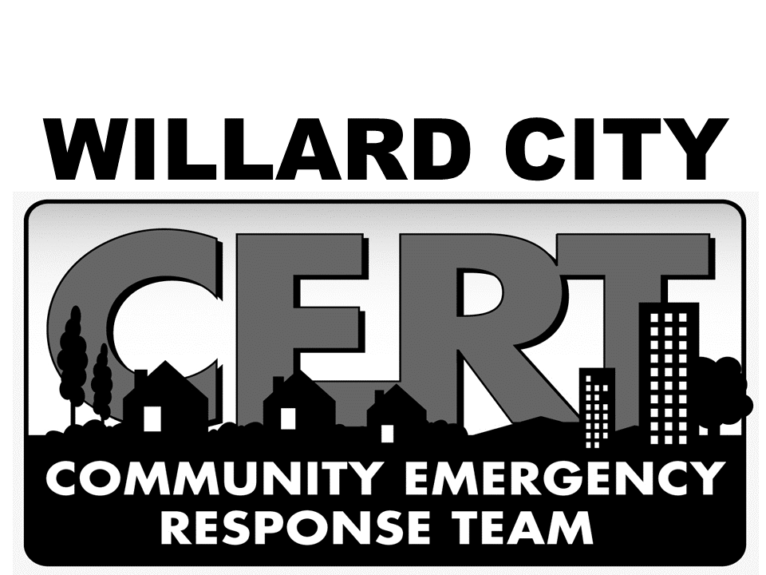
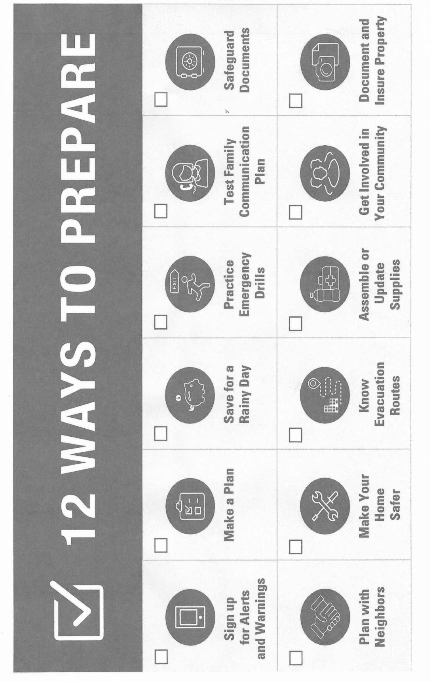
CERT “PREPPER” PAGE FEBRUARY 2024
2024 Monthly Preparedness Action Items
Don’t know where to start with Emergency Preparations? Try choosing one “Prep” topic and work on it for a month. Some of the above topics will take 20 minutes (Sign up for Alerts and Warnings), other topics will take all month(s). Information and instructions for several of the action items are included in the “Family Take Action” packet. These packets are available at no cost to all Community members. Download the packet from the Willard City website (willardcity.com) or contact Sue Anderson for your copy. ALL of the topics are covered, in detail, during CERT training classes. Hope to see you in class.

2024 SPRING C.E.R.T. TRAINING CLASSES

The spring C.E.R.T. (Community Emergency Response Training) Classes are scheduled to begin in MARCH. This training is provided to all Willard area residents as a public service by Willard City and Willard Fire Department.
These classes are designed to help all Citizens become better prepared for all types of emergencies and disasters.

Training sessions range from PERSONAL PREPAREDNESS to a wide variety of
FAMILY, NEIGHBORHOOD and COMMUNITY readiness.

Class Dates: Tuesday, March 5 & Thursday, March 7 6:00 PM Saturday, March 9 9 AM – 3 PM
Tuesday, March 12 & Thursday, March 14 6:00 PM Saturday, March 16 9 AM – 3 PM
Classes held at Willard City Office Building 80 West 50 South Cost: $10 per person. Saturday Lunch $5 / plate
We encourage every household to have at least one CERT trained family member.

Please call/text SUE ANDERSON 801 589-8270 or NOVA DUBOVIK 801 941-7798 to register for classes

